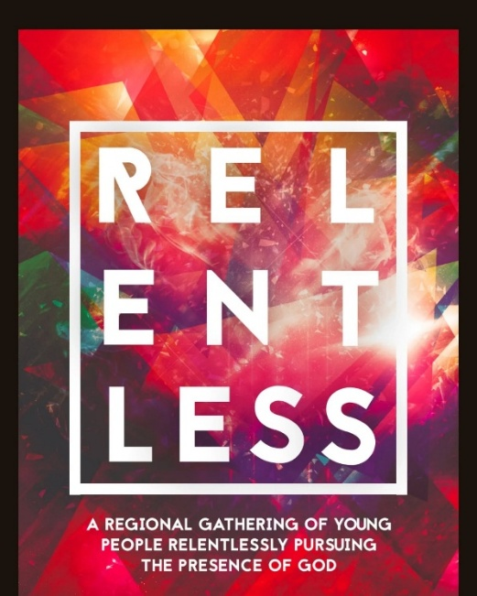

Regrettably we have to change the date of the next Relentless. Please ignore the previous email date of 16th Oct, it will now take place on Friday, 20th November! We apologize for this change and any inconvenience caused. We hope you can make this date and look forward to welcoming you.

We’re so excited to invite you and the young people in your church to Relentless, our upcoming regional youth event. It’s all about inspiring and encouraging young people to relentlessly pursue the presence of God, and we genuinely can’t wait for what’s in store.
📅 Date: Friday, 20th November 2026
🕖 Relentless: 7:00 PM -9.30pm
📍 Location: The Barn, Bidford Baptist Church, B504JN
We really believe this is going to be such a special evening of faith, fun, and community, and we would absolutely love to see the young people from your church there.
It would mean so much if you could help us spread the word - encourage your youth to come along, invite their friends, and be part of what we believe will be an unforgettable night!
If you have any questions or would like more details, please don’t hesitate to get in touch - I’d love to hear from you. You can contact me at emma@thebarn.org.uk.
We’re really looking forward to seeing you and your youth group at Relentless!
Emma King
Youth & Families Pastor

